**Part A: Cloud**

1. **(10 pts) Explain I/O rings in XEN**

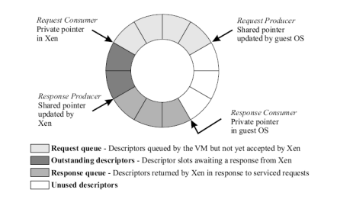

I/O rings, used for data transfer between Xen and Guest OS’es, use a circular buffer with 4 sections: Request Queue, Outstanding Descriptor queue, Response Queue, and a queue of unused descriptors.

* Requests from guest OS will be placed in the Request Queue,
* Once “accepted by Xen” they will be pushed to the Outstanding Descriptor queue to wait for responses from Xen
* Descriptors processed by Xen will then be placed in Response queue

There are 4 privilege levels: The highest ring is 0, where the kernel runs, or Supervisor Mode. The lowest is ring 3, where User applications run, or User Mode. Issuing "privileged instructions", from ring which is NOT ring 0, will trigger a protection fault. When running Xen, we run a Hypervisor in ring 0 and the guest OS in ring 1. The applications run unmodified at ring 3.

*Source:* [*https://wiki.xen.org/wiki/Introduction_to_Xen_3.x*](https://wiki.xen.org/wiki/Introduction_to_Xen_3.x)

1. **(10 pts) What’s the difference between Paravirtualization and full virtualization?**

|  |  |
| --- | --- |
| **Paravirtualization** | **Full virtualization** |
| * Guest OS **modified** * The virtual machine does not necessarily simulate hardware, but instead (or in addition) offers a special API that can only be used by **modifying** the guest OS * Requires porting (source code) * Execution overhead * Example: KVM Win4Lin 9x | * Guest OS runs **unmodified** * The virtual machine simulates enough hardware to allow an unmodified "guest" OS (one designed for the same CPU) to run in isolation * Guest OS sees exact hardware * Requires virtualizable architecture * Example: VMware |

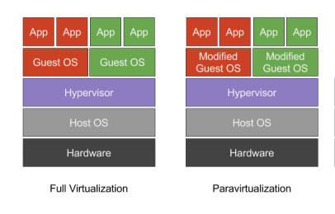

1. **(15 pts) Compare Xen and KVM in terms of virtualization technology.**

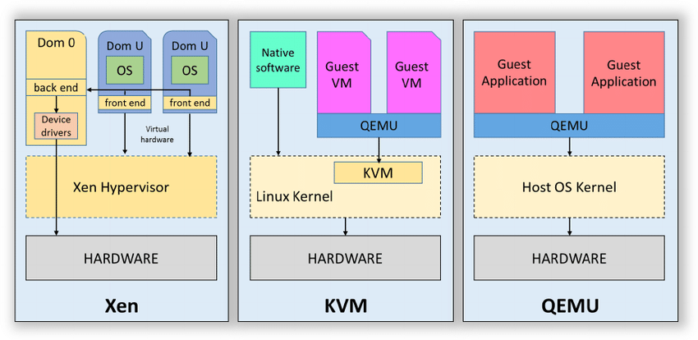

|  |  |
| --- | --- |
| **Xen** | **KVM (Kernel Virtual Machine)** |
| **Type 1 hypervisor (run on top of hardware) that allows multiple operating systems to execute simultaneously.** | **Works similar to a hypervisor, but is only a virtualization module in Linux kernel.** |

*Source:* [*https://www.researchgate.net/figure/Comparison-of-Xen-KVM-and-QEMU_fig1_281177318*](https://www.researchgate.net/figure/Comparison-of-Xen-KVM-and-QEMU_fig1_281177318)

**Part B: Data**

1. (45 pts) Create a JSON Merge tool. Please see the attached description in the doc  [MergingJson.pdfPreview the document](https://templeu.instructure.com/courses/74305/files/7681902/download?wrap=1).
   * You can work in the programming language of your choice. However, the same project will be subject to MapReduce, which we will cover in Java.
   * Test Data: [5by3.zip](https://templeu.instructure.com/courses/74305/files/7681985/download?wrap=1)